How to Use the Synergy Grade Book

Grade Book allows teachers to:
- Track student performance on assessments such as homework, quizzes, and projects
- Create progress reports and report cards
- Determine the assignments to make accessible to parents and students through ParentVUE and StudentVUE

Table of contents:
1) How to set up your grade book
Weighting
Add assignment types
2) How to create an assignment
3) How to grade an assignment
The “quick way”
The “more detailed way”
4) Posting Grades for Report Cards
5) Other Useful Information
6) Google Classroom Integration
7) Help

1) How to set up your grade book
Login to Teacher VUE, hover over the “Grade Book” tab, and select “Grade Book Setup”, then
select the focus/ grading period from the drop down menu in the top left corner.

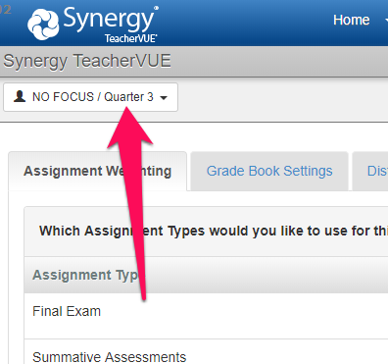

Weighting
On the Grade Book Setup tab, click on the “Assignment Weighting” tab, and enter the weight for each assignment type by percentage in the “Weight” column.. A box in the top right of the screen will tell you when you have reached 100%. The “Drop Scores” column will allow you to enter the number of assignments you want to drop with the lowest score. For example, entering “2” in the “Test and Quizzes” drop score column will drop the 2 lowest test and quizzes scores for each student.

Note: The “Default Points Possible” column is a way to add a 2nd layer of weighting to assignments. It is recommended that you keep this at “1.00” for all assignments types unless you are proficient with advanced weighting techniques.

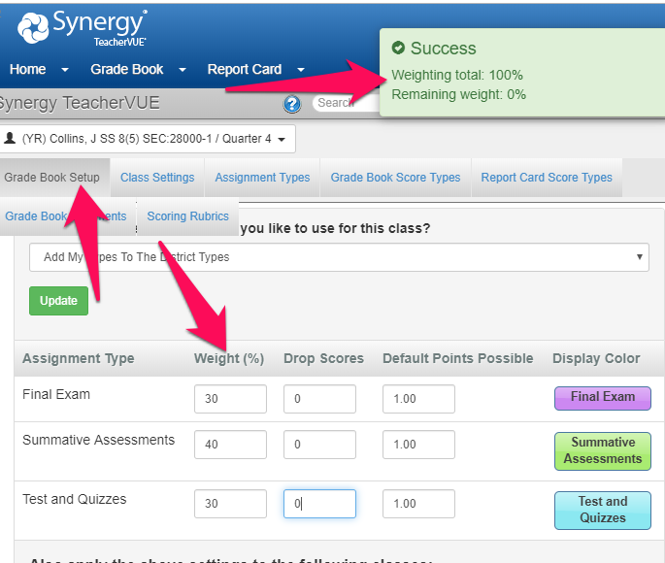

To apply weighting to all periods, check the “Select All Classes” box on the bottom of the “Assignment Weighting” tab. Or, you can select just the periods you want to apply the weighting to.
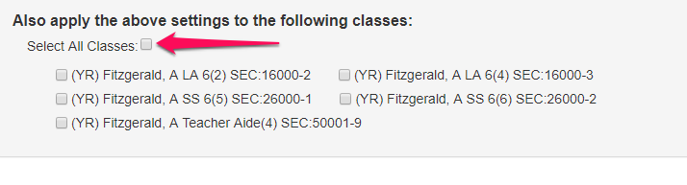

Add assignment types
Click on the “Assignment Types” tab (under Grade Book setup in the drop down menu). Click the “+NEW” button in the right side of the screen.
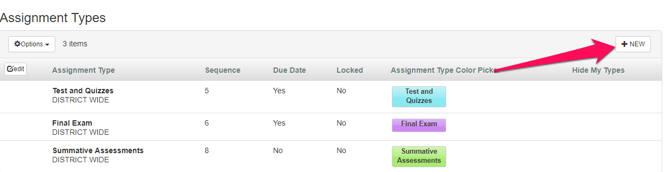

Type in the name of the assignment type. Then, type in a number for the order in which you’d like it to appear amongst all the other assignment types, select whether or not you’d like to be able to set a due date for the assignment type, and finally select a color for that assignment type. Then click “+INSERT” to save the new assignment type.
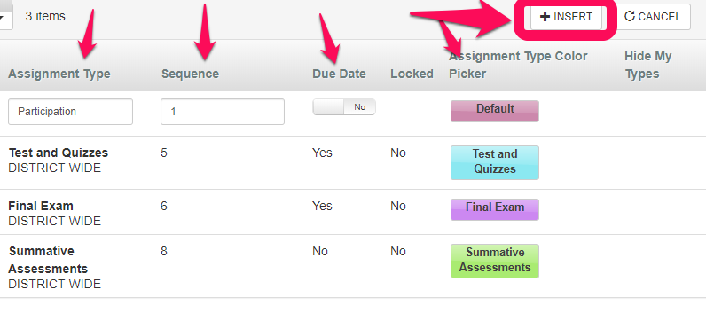
Note: Make sure to include new assignment types in your weighting, or they will not be calculated into the grade. Not weighting an assignment type is a useful way to keep track of student progress on something that will not be part of their final letter grade.

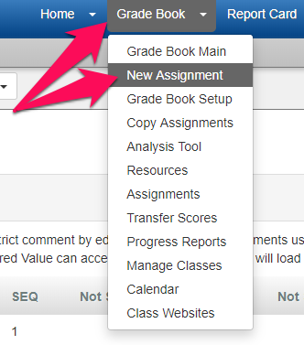
2) How to create an assignment
Hover over the “Grade Book” tab and then select “New Assignment” from the drop down menu.

Add an assignment name, select an assignment type and score type, and include a due date if applicable. If you select “percentage” as a score type, you will be required to enter the scores for that assignment as the percentage they received. If you select “raw score” as a score type, you will be required to select the number of points they received out of the total possible points. The grade book will then automatically calculate that into a percentage. When done, click “Save Assignment” in the top right corner.

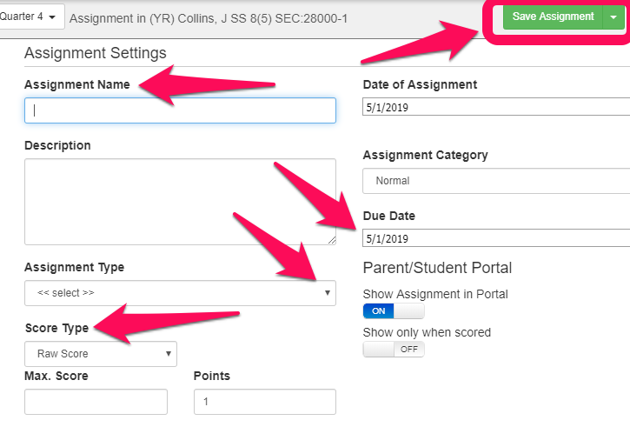

To add the assignment to multiple periods, click into the assignment, select the “Sections” tab from the bottom of the screen, and check the periods you want to add the assignment to.
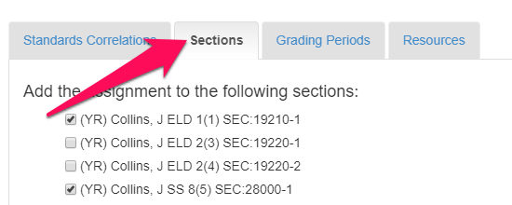

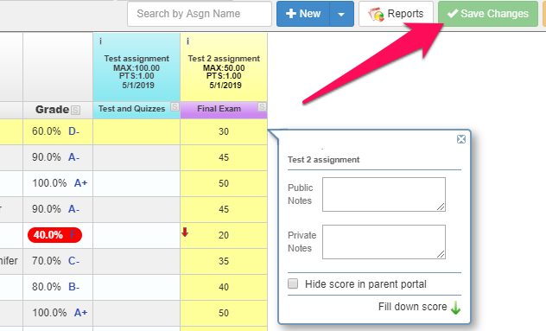
3) How to grade an assignment
There are 2 ways to enter scores for an assignment.

The “quick way”
Hover over the Grade Book tab, and select “Grade Book Main” from the drop down menu. This will display columns for each assignment. Click into the field next to a student’s name to enter a grade, and an optional public and private comment. The public comments will appear in Student and Parent VUE, the private comments will appear only to the teacher. Click the green “Save Changes” button when done.

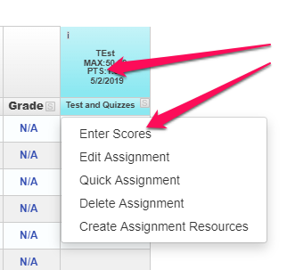
The “more detailed way”
From the main grade book screen, click on the title of the assignment in the column header, and select “Enter Scores”.
.
Then you will have the option to enter a score (and fill down), decide whether or not you want the score to appear in the Student and Parent VUEs, add comments, and add public and private comments.

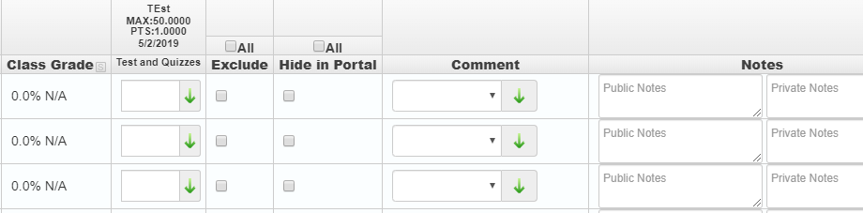

4) Posting Grades for Report Cards
Hover over the “Report Card” tab, and select “Students” from the drop down menu. The students’ grades will display for the current grading period as determined by your graded assignments and the weighting you set up. To edit the final grade and to make comments, select the “Edit Final Grade and Comments” button.

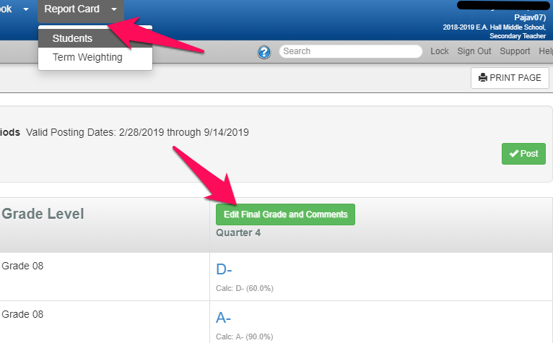

On the edit screen, you will be able to see their current grade, and then add a different final grade (if applicable), and add comment codes which references the comments displayed on the right of the screen. Click the green “Save Changes” button to save the changes.
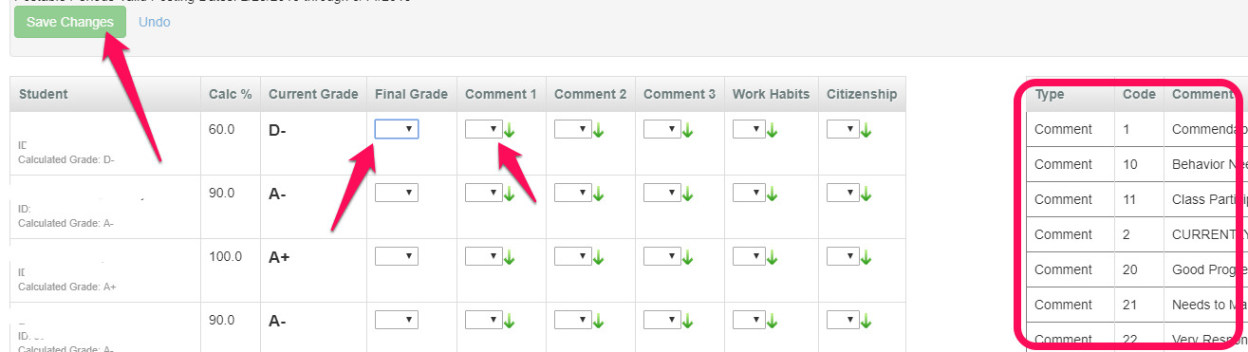

Once you have entered all the grades and comments, click on the green “Post” button to post the grades. This button will only be displayed when the grading window has opened. You can continue to edit and repost grades as long as the grading window is open (roughly 3 weeks). Once it has closed, you will not be able to change a student’s grades, and the “post” button will disappear.
Note: A yellow field indicates a grade has been edited by the teacher, and an orange field indicates that there are missing assignments that are affecting the students’ grades.

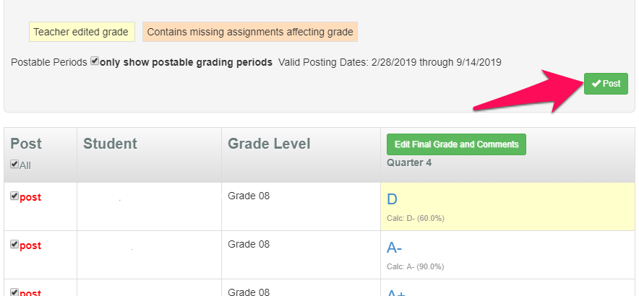

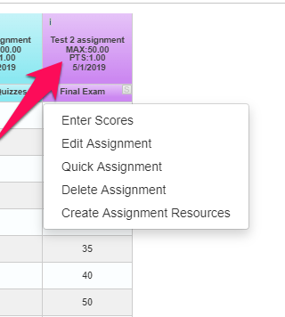
5) Other Useful Information
From the main grade book screen, you can click on an assignment and get the following quick options:
- Enter Scores: This takes you to a screen to enter detailed scores for just that assignment.
- Edit Assignment: This takes you to a screen to edit the assignment details. Note: you can’t change the score type for an assignment if you have already entered grades for the assignment. You will need to remove the grades before changing the score type.
- Quick Assignment: Allows saving assignments and scores across multiple classes, while saving all data entries in real-time.
- Delete Assignment: This will delete the selected assignment.
- Create Assignment Resources: Allows you to add a website or document as a resources to the selected assignment.

6) Google Classroom Integration
Stay tuned! This information will be posted here soon! The Google Classroom integration will be much easier with Synergy, and your assignments and grades from Google Classroom will automatically be imported into your Synergy Grade Book.

Click here for Synergy’s detailed information on their Google Classroom integration.

7) Help
On any screen in your Grade Book, you can click on the question mark symbol in the top right corner and get information for the current screen. The help menu is contextual, so it will provide information for what you currently have selected!
